Harrow Community Transport (Harrow CT) goes to Whipsnade Zoo

On a beautiful summer’s day on 4 June 2013, Harrow CT brought together the residents of Harrow for a wonderful day out to Whipsnade Zoo, near Dunstable in Bedfordshire. We set off at 10am from the Lodge and we reached the Zoo for 11am. On our way to Whipsnade we enjoyed listening to the radio commentary of the special service at Westminster Abbey to celebrate the 60th anniversary of the Queen’s coronation. We were all amused to hear that on 3 June 1953 London was dismal, dull and grey but the sun shone at the Abbey in its full glory to mark the 60 glorious years of the Queen’s reign!

As soon as we went inside the Zoo, we were all blown away by the panoramic scenery of the Dunstable Downs and Ivinghoe Beacon, a prominent hill and landmark in the Chiltern Hills. We all screamed ‘wow’ to express our pleasure and admiration. Gerry told us that the Chiltern Hills form a chalk escapement in South East England. They are known locally as “the Chilterns.” In 1965 a large portion of the hills was designated officially as an Area of Outstanding Natural Beauty.

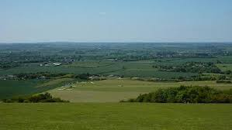
Dunstable Down and Ivinghoe Beacon

Whipsnade Zoo is an enormous place set in 600 acres of stunning scenery and rolling Chiltern Hills. Sandra and Eda were happy when Gerry told us that he would drive the group around the Zoo. Sandra said “it is far too far to walk around.”

Harker was most surprised to learn that the Zoo is home to 4671 animals!

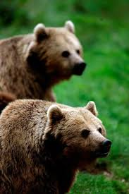
Brown bears

Our first stop was to meet brown bears. Zoo keepers were offering us carrots and apples to feed the bears. It was their feeding time. All of us had great fun feeding the bears. Zoo keepers asked us to throw the food avoiding the bears. Brown bears are truly omnivorous, taking whatever food they find along the way. Their powerful claws enable them to dig around for roots and flush rabbits and rodents out of their burrows. The diet usually consists of berries, nuts, roots, grass, insects, fish and rodents. Their long snout indicates that smell is an important sense for them. There are 3 bears at Whipsnade Zoo, two of them being twins, it was great to get a feel of the size and power of these animals, yet they still look quite cute, even when fully grown.

Veena was fascinated to see Harker making notes of the Zoo and animals for his wife. Harker told Veena that in the evening he would tell his wife how he spent the day in the Zoo!

After our meeting with the bears we went to see rhinos. They live in open grassland, eat short grass and weigh around 3,900 pounds. We learned that rhinos are short sighted but they have an excellent sense of smell. Believe it or not Harker was noting down all these facts for his wife most meticulously!!

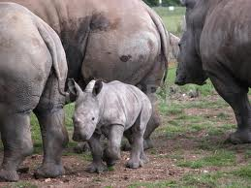
Rhinos at Whipsnade Zoo

By the time we finished our meeting with rhinos, we all were ready for a drink and refreshment. Gerry told us after the refreshment he would drive us around the Zoo without stopping to see individual animals. There was a lot to see and we planned to leave the Zoo by no later than 4pm. We all agreed with Gerry and saw the giraffes, lions, elephants, hippos, cheetahs, meerkats, ostriches and flamingos from our mini bus. Sandra was excited to see cheetahs and commented how graceful they were. Eda was amazed to hear that elephants ate 150kg of plant matter every day. The sight of orange flamingos was simply breath taking. Sandra said that they must eat salmon all the time to acquire such a beautiful orange colour!

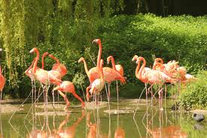
Flamingos in Whipsnade Zoo

It was 1.30 and people were eager to stop for lunch but Gerry, Sandra and Veena had a different agenda. They were anxious for a ride on the jumbo express. Gerry was so excited to see the train - he wanted to sit on the first or second carriage of the train so that he could smell the steam! Gerry said “it is the sheer magic of a steam-hauled railway. I love to hear the whistle and see the smoke – very few zoos have them.” Whilst on the jumbo express we spotted elephants, rhinos, yaks, camels and several other animals. With the exciting commentary, we three felt that we were on a safari adventure.

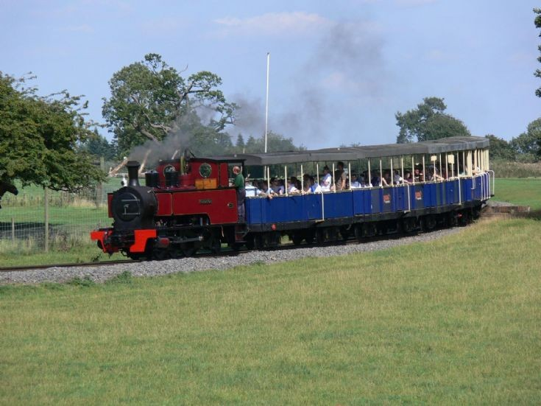
Jumbo Express at Whipsnade

After the train ride we met with the rest of the group in the cafe. Sandra bought some chips. Gerry and Veena went for a cuppa and scones!!

Because of the time constraint Gerry told us that we would leave the place after watching the penguins. The Zoo has the South African black footed, humbolt and rock hopper penguin troupes. These lively seabirds like nothing better than feeding time, when keepers give the peckish penguins their favourite dish of sprats. Penguins might look ungainly waddling around on land, but they come into their own in the water, where they swim around with incredible grace. We all had so much of fun watching penguins.

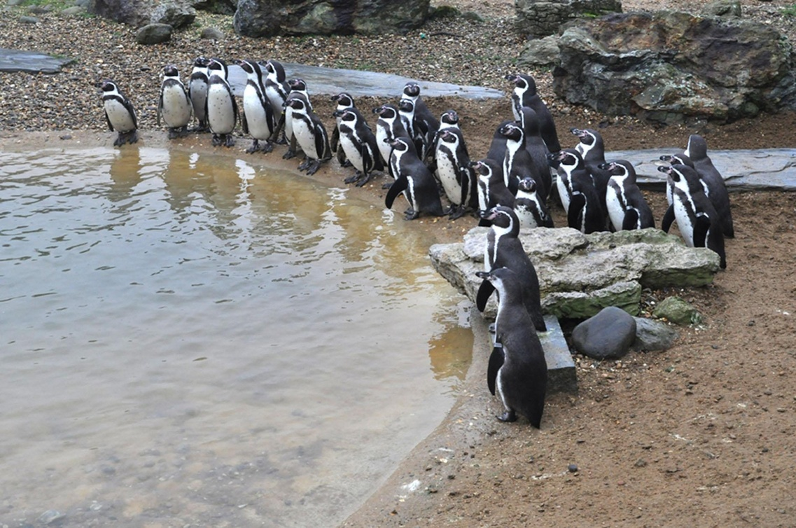
Penguins in Whipsnade Zoo

Before leaving the zoo Sandra, Harker and Veena went to the gift shops for souvenirs. Harker bought a book on the Zoo so that his wife knows all about Whipsnade!! All of us enjoyed it so much that we said to one another that we could easily spend another day at the Zoo. We left with some fond memories of the place and thanked Harrow CT for a truly memorable day.

